Police Report February 2017
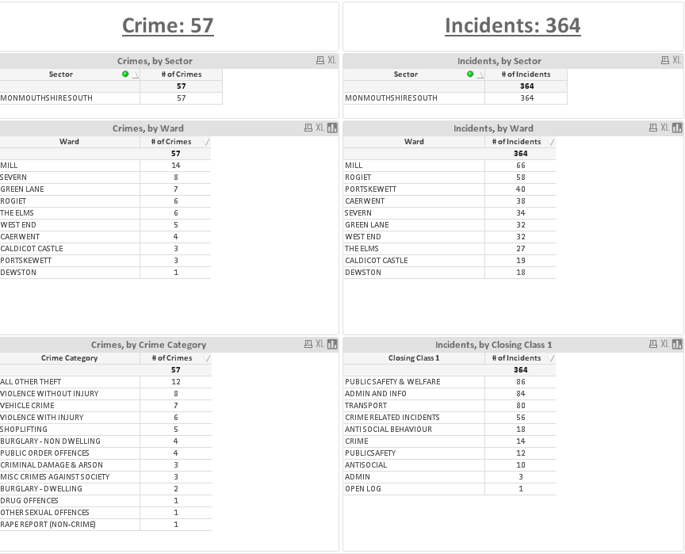

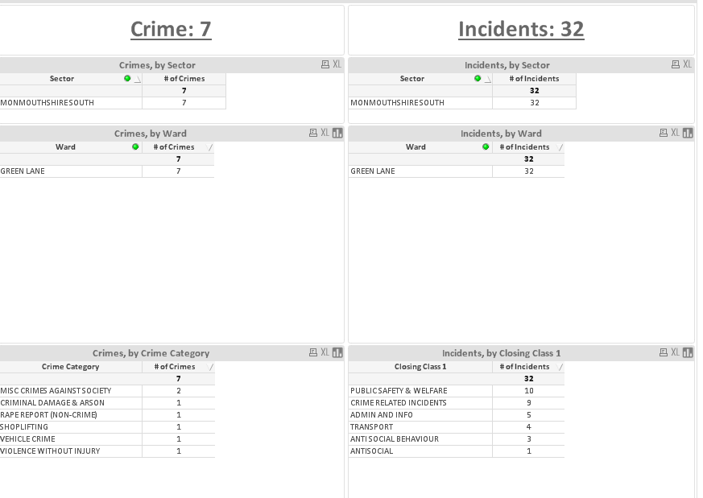

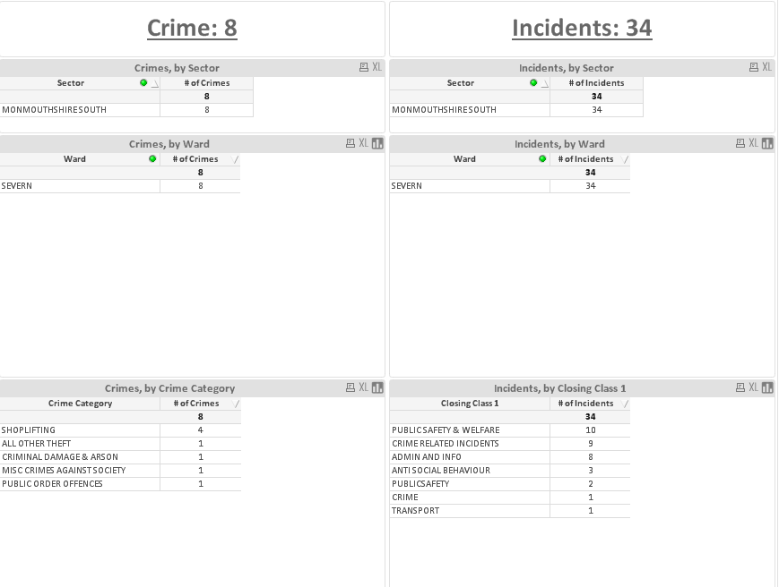
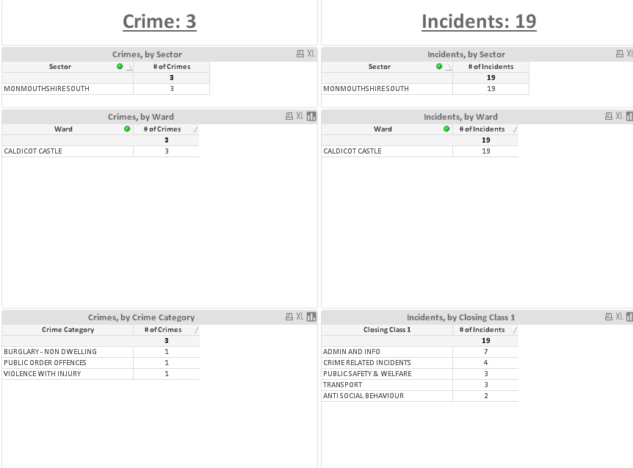
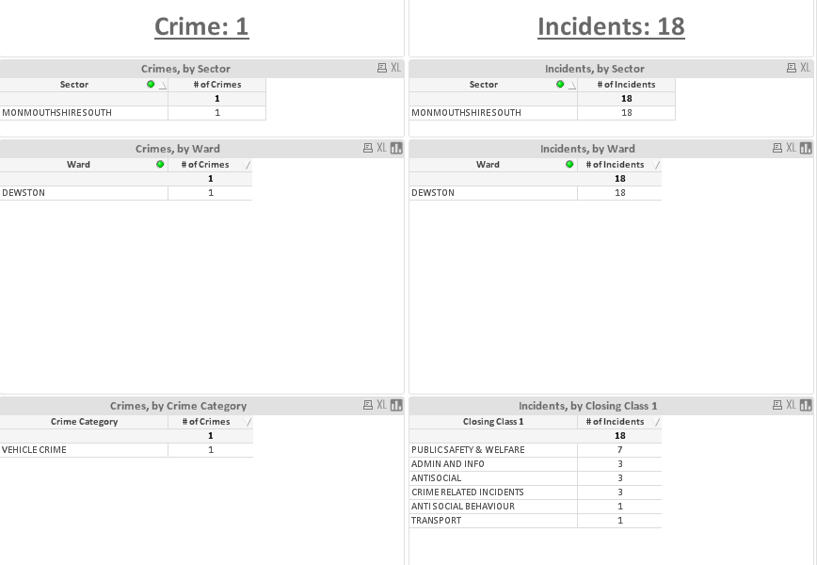

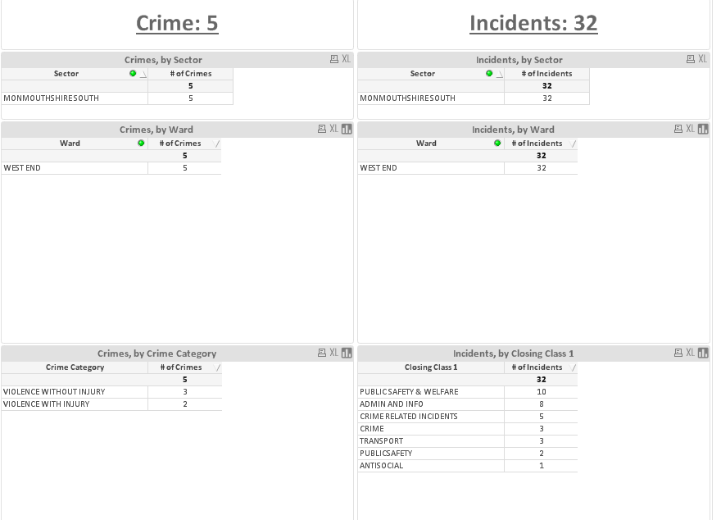

The above crime figures relate to incidents from 1st February to 17th February inclusive.

Dewstow Ward
Your Voice Priority – Parking Problems
With regards to the Your Voice Priorities I have been in contact with the Dewstow Councillors and some have replied and they seem in agreement that patrols in the areas of Sandy Lane/Castroggi/Dewstow School & Woodland View have had an impact in reducing illegal parking and I have not had any parking offences in the last few weeks. Due to the fact that these streets relate mainly to school parents dropping off/picking up which is only for short periods of time, this is something that can be dealt with by me and the team as part of our normal patrols. There is no evidence to support any real issues in these areas. verbal warnings have been given to residents who I have identified as parking causing an obstruction to other road users/pedestrians accessing the pavement and the parking appears to be improved.
Any concerns from residents please ask them to log it on 101 so officers can attend at the time and deal with any offences. I will look to close this Ward Priority down.
Severn Ward
Your Voice Priority – Mill Lane Parking Problems.
CO164 Martin has made several visits to the location during January/February and has not issued any tickets and has not reported any concerns whilst he has been on patrol. Cllr Higginson has emailed CO38 Brown over the weekend to raise more concerns from residents in this area to do with illegal parking on junctions stopping on occasions bin collections. Patrols will continue by the Neighbourhood Team after half term.
Westend Ward
Your Voice Priority – Drugs Longfellow Road.
Patrols have been made by CO164 Martin and the team during shift patrols, No new intelligence has come to light since the creation of the plan.

Castle Ward
Your Voice Priority – Parking on Church Road (School Times)
CO14 Norville covers this ward he recently met with Highways and Representatives of Castle Park School to look at the parking problems on Church Road. He has also asked for the minutes of previous meetings in relation to this problem. He is currently getting some safety/parking leaflets together for distribution by the school to all pupils to try to educate parents on safe parking etc.
Regular patrols have been carried out by CO14 and the team with 1 warning and 1 fixed penalty notice issued for parking blocking the pavement.
Green Lane Ward
Your Voice Priority – Anti-Social behaviour around Newport Road/King George V Playing Fields.
We have seen a large decrease in Anti-social calls around the town centre with over 60 youngsters accessing Positive Futures Free Football Friday event at Caldicot Leisure Centre on the one evening. This is proving very popular with the youngster and keeps them off the streets until it closes at 9pm.
I have been in touch with Choices “Drug & Alcohol” agency, and they are looking to do some outreach work around the town centre/skate park with the youngster over the next few weeks. So I will let you know how this goes when I hear back of them.
Patrols will continue in these areas as part of our regular patrols to deter ASB around the area.
Other things of note.
Also 2 reported house breaks and 1 attempt break in the Severnside area over the last weeks, also 2 vans broken into with tools stolen. We have put out social media messages via Twitter/Gwent Now. Enquiries are still on-going in relation to these although we have some real positive intelligence in relation to the house breaks and have possible suspects from the Newport area that are being looked at by CID.

