Caldicot Town Council

Cyngor y Dref Cil-y-Coed

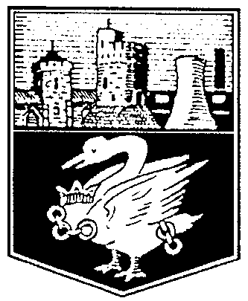

Council Office, Sandy Lane, CALDICOT NP26 4NA

Swyddfa’r Cyngor, Lôn Dywodlyd, CIL-Y-COED NP26 4NA

CEMETERY FEES

with effect from 1.4.18

Scattering Ashes £ 60
Opening New Single Grave £300
Opening New Double Grave £300
Opening New Triple £300
Re-open Existing Grave Space £300
Burials under 16 £ 0
Cremated Remains in CRS Area £120
Cremated Remains in Existing Grave £120
Cremated Remains in New Grave £300

Headstones
New Headstone £130
CRS Headstone £130
New Inscription £130
Under 16’s £ 0

Please note temporary cessation of New Grave/CRS Spaces for Non-residents of Caldicot

Double fees for deceased persons outside Caldicot (5 year rule)

As at 1st April 2017 - No CRS/Burial reservations

Gail McIntyre
Clerk to the Council

Telephone/Ffôn: (01291) 420441, Fax/Ffacs: (01291) 431139

e-mail/e-bost: towncouncil@caldicottc.org.uk

website/gwefan: www.caldicottc.org.uk, Facebook: Caldicot Town Council

Clerk and Finance Officer/Clerc a Swyddog Cyllid: Mrs Gail McIntyre

